LABORATORY CHAPTER №3

Topic 1: OPERATING SYSTEM

Basics:
An operating system is the program that, after being initially loaded into the computer by a boot program, manages all the other programs in a computer. The other programs are called applications or application programs. The application programs make use of the operating system by making requests for services through a defined application program interface (API). In addition, users can interact directly with the operating system through a user interface such as a command language or a graphical user interface (GUI). For hardware functions such as input and output and memory allocation, the operating system acts as an intermediary between programs and the computer hardware, although the application code is usually executed directly by the hardware and frequently makes system calls to an OS function or is interrupted by it.

Major operating system functions:
- CPU management - division of tasks into manageable pieces and distributing them on the priorities before sending to the processing of the CPU;
- Memory management - coordination of the data flow in and out of RAM and determining the need for virtual memory;
- Device Management - providing communication between each device connected to a computer, CPU and requests;
- Data management - a direction of data storage for a long time on hard drives and other storage devices extended;
- Application Interface - providing a standard communication and data exchange between application programs and components;
- User Interface - providing ways to communicate and interact with the computer.

Depending on the number of simultaneously processed tasks and the number of users, which can be catered, there are four common types of operating systems:
- single-user single-tasking, which support a single input source and can be operated with only one (current) task at a time;
- single-user multi-tasking, which provide to a single user parallel processing of multiple tasks;
- multiple users multi-tasking, allowing to run multiple tasks to multiple users on a single computer.
- real-time operating system, guarantees to process events or data by a specific moment in time. A real-time operating system may be single- or multi-tasking, but when multitasking, it uses specialized scheduling algorithms so that a deterministic nature of behavior is achieved.

Personal computer Boot-up sequence
A PC cannot do anything useful unless it is running its operating system It sets the rules for using memory, drives, and other hardware devices on the computer. Before a PC can run the operating system, it needs some way to load it from disk into RAM. The way to do this is with the bootstrap – a small amount of code that is executed on startup or system boot. The boot-up sequence of events is as follows:
1. The computer loads the basic input/output system (BIOS) from ROM. The BIOS provides the most basic information about storage devices, boot sequence, security, Plug and Play (auto device recognition) capability and a few other items.
2. The BIOS triggers a test called a power-on self-test (POST) to make sure all the major components are functioning properly. You may hear your drives spin and see some LEDs flash, but the screen, at first, remains black.
3. The BIOS has the CPU send signals over the system bus to be sure all of the basic components are functioning. The bus includes the electrical circuits printed on and into the motherboard, connecting all the components with each other.
4. The POST tests the memory contained on the display adapter and the video signals that control the display. This is the first point you’ll see something appear on your PC’s monitor.
5. During a cold boot the memory controller checks all of the memory addresses with a quick read/write operation to ensure that there are no errors in the memory chips.
6. The computer loads the operating system (OS) from the hard drive into the system’s RAM. That ends the POST and the BIOS transfers control to the operating system. Generally, the critical parts of the operating system - the kernel- are maintained in RAM as long as the computer is on. This allows the CPU to have immediate access to the operating system, which enhances the performance and functionality of the overall system.

32-bit or 64-bit OS?
The answer commonly depends on which type of processor is used. Modern computing has been shifting towards 64-bit for a few years now, and it has saturated the market to a point where even entry-level computers are equipped with these new, more powerful processors.
A 32-bit operating system will run efficiently at 4 GB memory, but no more than that. This is because its architectural design won’t exceed a certain integer value, the addressable space. That integer value refers to your “bit” which is binary (0 or 1). Now if you have a 32-bit, you’ll have 2(0 and 1)³², which would then be equal to 4 billion bytes or 4GiB of addressable space.
With your 64-bit, the calculations would still be the same as with your 32-bit. So if you now have a 64-bit, you’ll have 2⁶⁴ that would total up to a large 16 Exbibyte (1.1529215 × 10⁹ gigabytes). It would now be your addressable space. However, since most of it won’t be fully utilized, OS’s will have its limits like a 64-bit Windows with a maximum 8 TB.

Topic 2: SOFTWARE

As we know what computer is a machine which cannot do anything without instructions from the user. In order to do any specific job you have to give a sequence of instructions to the computer. This set of instructions in a proper sequence is called a computer program. Software refers to the set of computer programs that cause the hardware (computer system) to function in the desired manner. Hardware means physical components of the computer system. We can say that hardware which cannot perform any calculation, comparison or manipulation without being instructed to do so. These instructions play a vital role in the performance of a computer. A complete set of instructions written to solve a problem on a computer is called software.
Traditionally, software has been divided into two different categories: systems software and applications software:
System software
System software “allocated” directly on top of your computer's hardware components. It includes the range of software you would install to your system that enables it to function. This includes the operating system, drivers for your hardware devices, linkers and debuggers. Systems software can also be used for managing computer resources. Systems software is designed to be used by the computer system itself, not by users.
Applications software
Unlike systems software, applications software is designed to be used by end-users. Applications software, in essence, sits on top of system software, as it is unable to run without the operating system and other utilities. Applications software includes: database programs, word processors and spreadsheets, e-mail applications, computer games, graphics programs and such. Generally, users will refer to applications software as software.

Malware
We have a whole selection of software that may come bundled under the name of malware. Short for malicious software, malware is any software that has been designed (programmed) specifically to damage or disrupt a computer system. The most common forms of malware are computer viruses, worms, and trojans.
Adware and Spyware
Other common types of software are adware and spyware. Adware is considered a legitimate alternative offered to consumers who don't wish to pay for software. Today we have a growing number of software developers who offer their goods as "sponsored" freeware until you pay to register. Generally most or all features of the software are enabled but you will be viewing sponsored advertisements while the software is being used. If you're using legitimate adware, when you stop running the software, the ads should disappear, and you always have the option of disabling the ads by purchasing a registration key.
Unfortunately some applications that contain adware track your Internet surfing habits in order to serve ads related to you. When the adware becomes intrusive like this, then we move it into the spyware category and it then becomes something you should avoid for privacy and security reasons.
Spyware works like adware, but is usually a separate program that is installed unknowingly when you install another application. Once installed, the spyware monitors user activity on the Internet and transmits that information in the background to someone else. Spyware can also gather information about e-mail addresses and even passwords and credit card numbers.Unlike adware, spyware is considered a malicious program.

TOPIC 3: FILE EXTENSIONS

A file is the common storage unit in a computer, and all programs and data are "written" into a file and "read" from a file. All files have their own name and extension. There are different types of computer files, designed for different purposes. A file may be designed to store a picture, a written message, a video, a computer program, or a wide variety of other kinds of data. Some types of files can store several types of information at once. By using computer programs, a person can open, read, change, and close a computer file. Computer files may be reopened, modified, and copied an arbitrary number of times. Typically, files are organized in a file system, which keeps track of where the files are located on disk and enables user access.
By the way, the folder (directory) on your computer is also a file, but only contains information about the files contained in it (in fact, these are containers that are located inside another container). You can create folders using the operating system, but to create most types of files you will need to use special programs (for example, application software - text, video, audio editors).

The file extension is the part of a file name that comes after the "." (e.g. in the fileext.doc, "doc" is the file extension, and this tells the computer what type of file it is looking at, in this case an Microsoft Word file. Windows, by default, does not display file extensions.
To view file extensions Click the “Organize” button on Windows Explorer’s toolbar and select “Folder and search options” to open it.
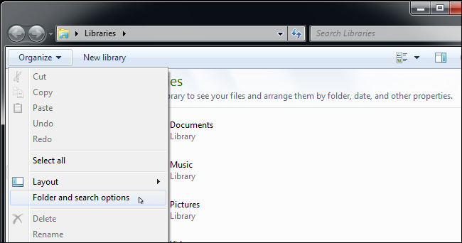
Click the “View” tab at the top of the Folder Options window. Disable the “Hide extensions for known file types” checkbox under Advanced settings. Click “OK” to change your settings.
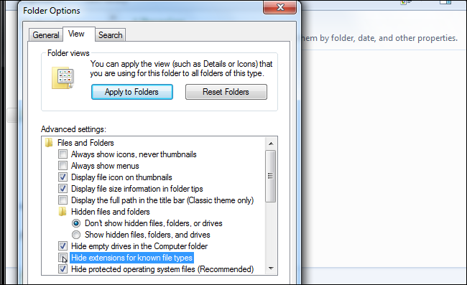
This options window is also accessible on Windows 8 and 10—just click the “Options” button on the View toolbar. But it’s faster to quickly toggle file extensions on or off via the ribbon.
This window is also accessible via the Control Panel on any version of Windows. Head to Control Panel > Appearance and Personalization > Folder Options. On Windows 8 and 10, it’s named “File Explorer Options” instead.

Changing the file extension
Most programs save work in a particular format, so a Word document when saved defaults to a .doc (.docx) extension. However a different file type can be selected by changing the "save as type" in the particular program menu pane: FILE - SAVE AS box. So, for instance, if you want to save an Microsoft Word 2010 document in a Adobe PDF file format (they use different extensions) you would select “Adobe PDF” from the “Save as” list.
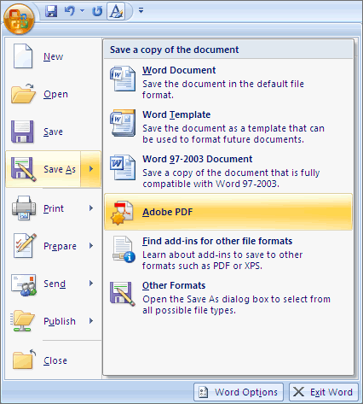
You must use “Save as” command each time when changing a file type – you cannot simply change the file extension by renaming a file in File Manager as this does not change the file format.

Common file extensions
Text file extensions
.pdf | Adobe Acrobat "Portable Document Format" as used by the Acrobat Viewer/Editor
.rtf | "Rich Text Format" a more portable document format from Microsoft Word
.txt | A very simple Text file (ASCII characters) NotePad could read and createit
Image file extensions
.psd | Adobe PhotoShop image
.cpt | Corel Photo-Paint image
.tif | "Tagged Image File Format" high quality image format, the standard for scanning images (can be imported by Quark Express). Often used to exchange files between different operating systems. Uses "lossless" compression to limit the file size without losing detail
.bmp | “Bit-Mapped Picture” the standard Windows format for bitmaps, normally uncompressed data which takes up quite a bit of space
.gif | Graphics Interchange Format" this was developed for sending compressed files over a network
.jpg | "Joint Experts Photographic Group" used for Web graphics, handles 16 million colours
Microsoft Office file types
.doc (.docx) | Microsoft Word
.xls (.xlsx) | Microsoft Excel
.mdb (.mdbx) | Microsoft Access
.ppt (.pptx) | Microsoft Powerpoint
.mpp | Microsoft Project standard file type
.mpw | Microsoft Project database file
Other common file types
.avi | "Audio-Video Interleave" the Windows standard for video (movie) files
.dll | "Dynamic Link Library" Windows system file, extensions for specific system software
.exe | Executable program file. If you double click one of these from the file management system the program will start (execute)
.htm or .html | "Hypertext Mark-up Language" standard format for Internet documents (Web pages) text and controls. View it using a Web Browser
.mpg | Motion Picture Experts Group" high quality video file format (movies)
.tmp | Temporary fil
.zip | A file that has been compressed with the zip format

ADDITIONAL TASK FOR MASTERING SKILLS

Task 1. Receive basic information about your workstation
The simplest way:
  - Click Start and select Control Panel from the Start menu.
  - In the Control Panel window, click System and Security.
  - In the System and Security window, click System.
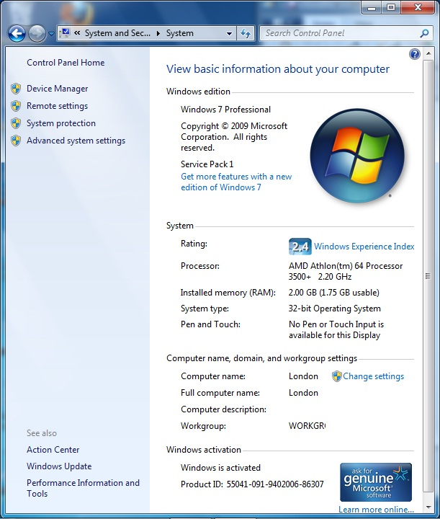

Tips: To get information about installed OS quickly (for Windows)
- Open prompt command line:
- Press + R on your keyboard OR
- Click Start and type cmd (cmd.exe) in command line OR
- Open Task Manager with more details. Choose File and then Run New Task. Type cmd or cmd.exe, and hit OK to open up a regular command prompt OR
- Open the Start menu, and click/tap on All apps at the bottom. In All apps, scroll down and expand the Windows System folder, then click/tap on Command Prompt. (for Windows 10).
- In prompt command line type: “winver” (without quotes)

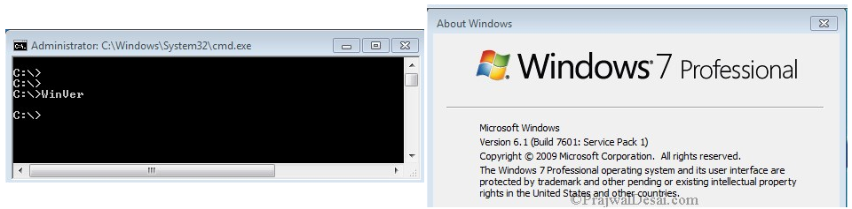

  - Create Folder D:\”Group Name” ICTLABS\ (without quotes)
  - In your folder create Microsoft Word document “Student Name_Lab№1.docx”
  - Write down the following data into the table titled “Lab1_task1”:

№ | Student Name
 | Faculty
 | Group
 | PС№/Name/Workgroup
 | Windows edition
 | Processor
 | Installed memory total
 | Installed memory usable (32x systems only)
 | System type
 | Windows activation status
 | BIOS version
 | Available RAM space
 | Total/available virtual memory
 | Hardware Information | Path to created file

NOTE: To fulfill 10 - 12 you have to access System Information window:
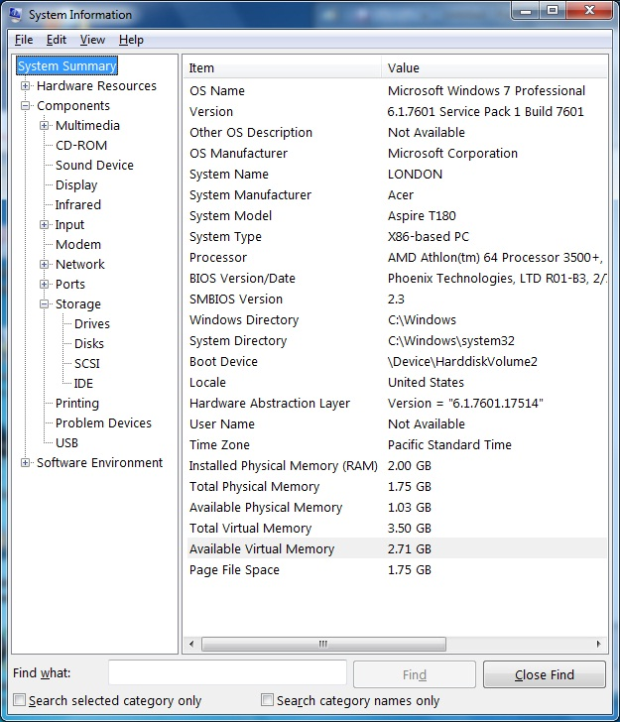
- Open prompt command line
- In prompt type: “msinfo32” (without quotes)
OR
- Click "Start" on the Taskbar
- Go to "All Programs"
- Go to "Accessories".
- Go to "System Tools".
- Click "System Information".

NOTE: To fulfill 13 - in the System Information window:

- Click and select the Drives category below Storage (wait for the system information to refresh on the right pane)
- Click File and Save
- Save Drivers information in txt file in your Lab. Folder (type path in table).

